aeLoader Startup Error for 2005
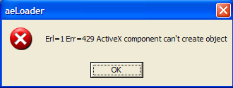

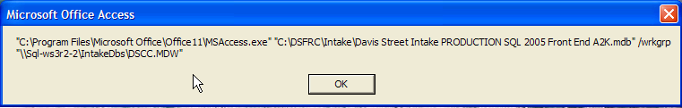

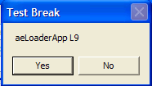

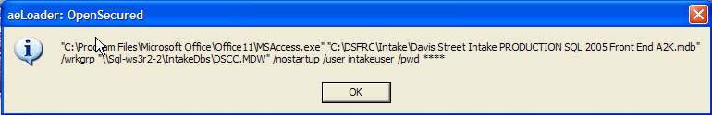

NOTE: The error is due to the password. The stars are from copying the record, so the password has to be manually entered in the table. Fixed.

INTAKE DB:
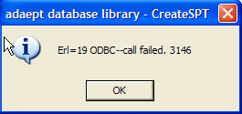

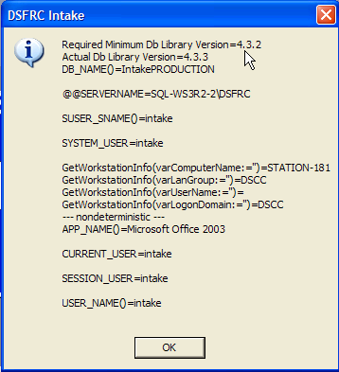 Fixed.

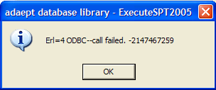

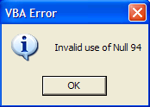 When ReRegister first record

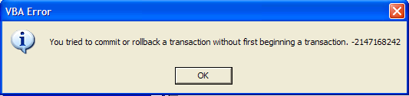

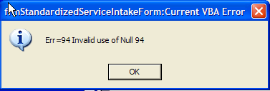

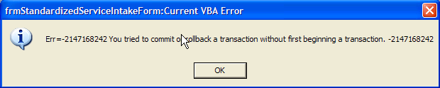

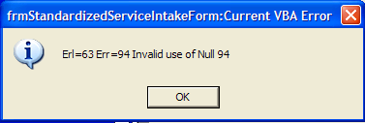

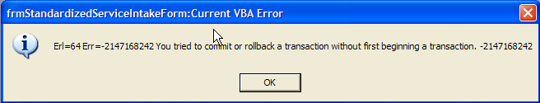

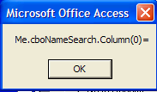

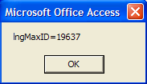

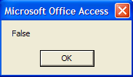 => 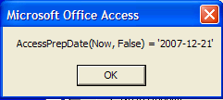

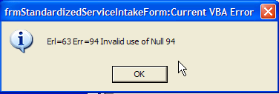

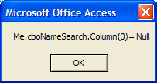 Fixed.

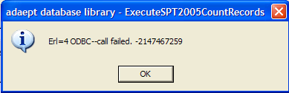

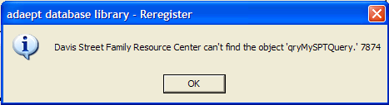

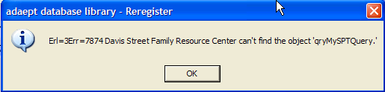 Fixed.

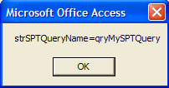 Fixed.

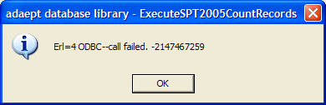

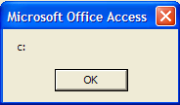

When testing with DAO reference:
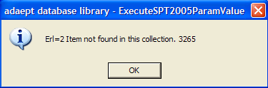 (red herring)

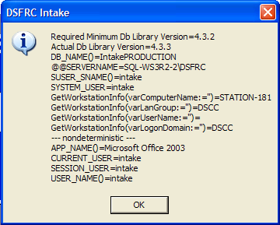 Fixed.

Public Function GetSQLinfo2005(strParameterName As String) As String

1: Dim aeSPT As New aeSPT2005Class
2: On Error Resume Next
3: DoCmd.DeleteObject acQuery, CurrentDb().QueryDefs(gconaeLibSPT)
4: aeSPT.CreateSQL2005PassThrough(gconaeLibSPT, SetConnectString(True), "Select " & strParameterName) = True
5: GetSQLinfo2005 = aeSPT.ExecuteSPT2005ReturnParamValue(gconaeLibSPT)

End Function

NOTE: This works but is slow as it creates and calls the SPT for each parameter value passed. It can be faster by creating one query, passing an array of parameters, changing the command text and running the query. Add a timing value to the result for performance comparison.

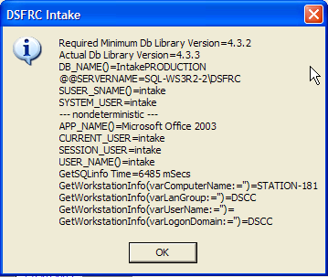

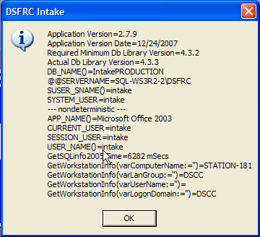

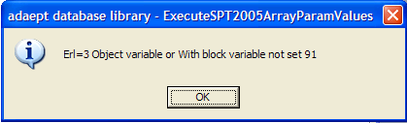

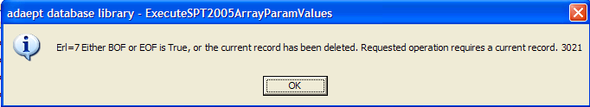

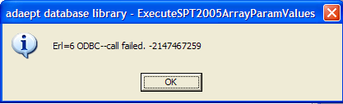

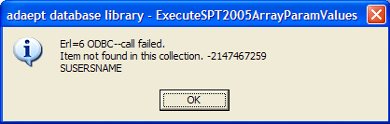

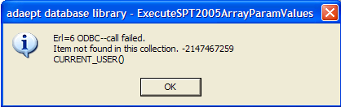

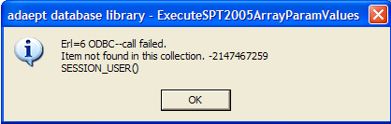

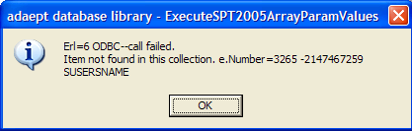 Fixed.

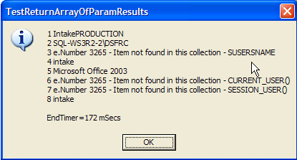 Library test.

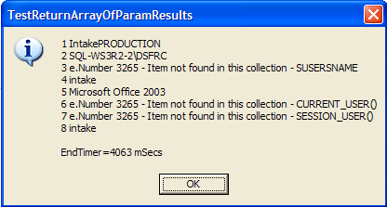 Application test.

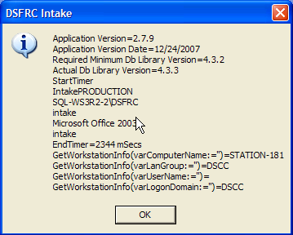 GetSQLinfo2005MultipleParamsDb

Get SQL info on first cmdAbout click and store in mastrSQLparams()
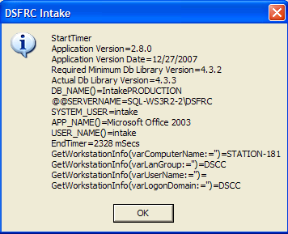

Second click, using IsArrayAllocated

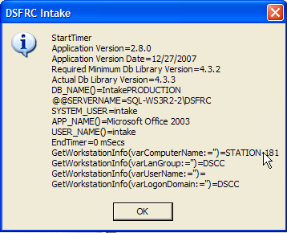 Fixed.

